ACCOMPLISHMENT REPORT
IT 307 & 307L – Event-Driven Programming
Month: August & September – Year: 2025
School Year: 2025 – 2026 1st Semester

DATE | ACCOMPLISHMENT | REMARKS  (Progress and deviations from the plan) *
October 1 – 11, 2025 | Lecture Accomplishments:  - Conducted a comprehensive review of Module 1: Introduction to Event-Driven Programming, Event Handling Concepts, Delegates and Events, revisiting the principles, architecture, and workflow of event-driven programming and its difference from procedural and object-oriented approaches.  - Re-explained event sources, listeners, handlers, event bubbling/tunneling, and synchronous vs. asynchronous event processing, emphasizing how these affect program flow and responsiveness.  - Reviewed the use of delegates and events, including creating and invoking delegates, multicast delegates, and raising events, to strengthen students’ conceptual understanding before the midterm.  - Recapped the practical applications of EDP in desktop, web, and other interactive systems, connecting concepts to real-world event-driven applications discussed in August–September.  Laboratory Accomplishments:  - Facilitated hands-on review exercises using existing JavaScript and PHP event-driven programs where students identified and explained event-handling behavior.  - Conducted code tracing and debugging tasks for simple GUI/event-driven examples to reinforce understanding of how events propagate and how handlers are triggered.  - Guided students in refining earlier lab outputs (from August–September) by improving secure coding practices, error handling, and basic documentation in their event-driven programs.  - Provided focused remediation/consultation sessions for students who had difficulty with asynchronous events and error handling, in preparation for the midterm lecture and lab exams. | Accomplished  (Modules 1 and 2 were systematically reviewed to prepare students for midterm written and laboratory examinations.)
October 13 – 17, 2025 | Lecture Accomplishments [EXAMINATION WEEK]:  - Administered the Midterm Written Examination covering:  - Principles and architecture of event-driven programming,  - Event handling concepts (bubbling, tunneling, synchronous vs. asynchronous),  - Delegates and events, secure coding, and basic error handling.  - Implemented standard exam procedures and protocols (instructions, time management, seating arrangement, integrity reminders).  - Checked, scored, and recorded midterm lecture exam results for grading and documentation.  - Provided brief post-exam feedback, clarifying common misconceptions and highlighting strengths/areas for improvement.  Laboratory Accomplishments [EXAMINATION WEEK]:  - Checked and documented laboratory midterm outputs (source codes, screenshots, and performance ratings) as evidence of completion.  - Aggregated and recorded lab exam scores as part of the laboratory midterm grade. | Accomplished  (Midterm lecture and laboratory examinations were administered; results was released to students immediately)
October 20 – 24, 2025 | Lecture Accomplishments:  - Officially started Module 3: Multi-Page Web Applications, File Handling, API Integration, and Testing & Debugging (PHP + JavaScript) and presented the module’s intended learning outcomes (secure coding, integration with APIs, and robust event-driven web workflows).  - Discussed how to structure multi-page PHP applications, including navigation between pages using GET, POST, query strings, and basic layout reuse with includes (header/footer).  - Introduced sessions and cookies as mechanisms for maintaining user and application state in an event-driven web environment.  - Presented foundational concepts in file handling, including reading/writing text files and the basics of secure file uploads (validation, MIME type checking, and filename sanitization).  Laboratory Accomplishments:  - Guided students in implementing a basic multi-page PHP application with simple navigation and data passing between pages through forms and query strings.  - Conducted a hands-on exercise on using $_FILES to handle file uploads, emphasizing server-side validation and safe storage practices.  - Encouraged students to test form submissions and file operations, observe resulting events and server responses, and log any errors for debugging.  - Began building a small step-by-step lab project that will later incorporate file downloads and simple API integration as Module 3 progresses. | Accomplished  (Module 3 was introduced and initial topics on multi-page web applications and file handling were covered with corresponding laboratory implementation.)
October 27 – 30, 2025 | Lecture Accomplishments:  - Continued discussion on secure file handling in web applications, including size limits, permitted file types, and server-side checks to prevent misuse.  - Explained how to implement file download features using PHP (setting appropriate headers and controlling access to downloadable files).  - Introduced the concept of API integration in event-driven web applications, highlighting the role of HTTP requests, responses, and error handling in asynchronous workflows (to be deepened in succeeding weeks).  - Emphasized testing and debugging strategies for multi-page and file-based applications, connecting these to reliability and ethical coding practices.  Laboratory Accomplishments:  - Extended the ongoing Module 3 lab project by adding file download functionality, enabling students to work with both upload and download processes in their multi-page application.  - Conducted debugging and testing sessions where students identified and fixed common issues (incorrect file paths, headers, validation logic, and form handling errors).  - Guided students in designing basic logging or reporting mechanisms (e.g., simple records of uploads/downloads) to simulate real-world monitoring of event-driven web systems.  - Collected and documented lab outputs and screenshots as proof/evidence of Module 3 progress. | Accomplished  (Module 3 coverage was continued with focus on secure file handling, download implementation, and initial API concepts, preparing students for deeper integration and testing in the following month.)

*Provide relevant documentation such as pictures, summary reports, etc.

Prepared by: Approved:

JUNNIE RYH M. SUMACOT SHERWIN G. CADAY, PhD.
Instructor Program Chair

PROOF/EVIDENCE OF REPORTED ACCOMPLISHMENTS
IT 307 & 307L – Event-Driven Programming
Month: October – Year: 2025
School Year: 2025 – 2026 1st Semester

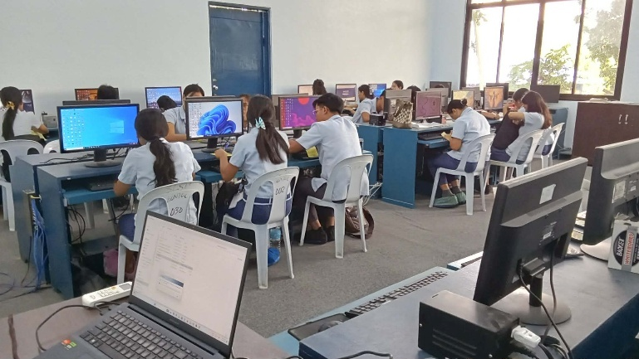
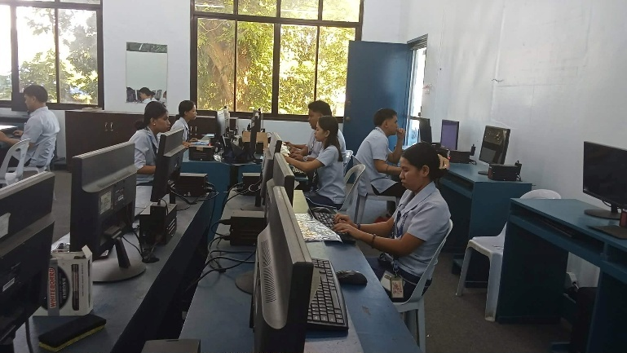
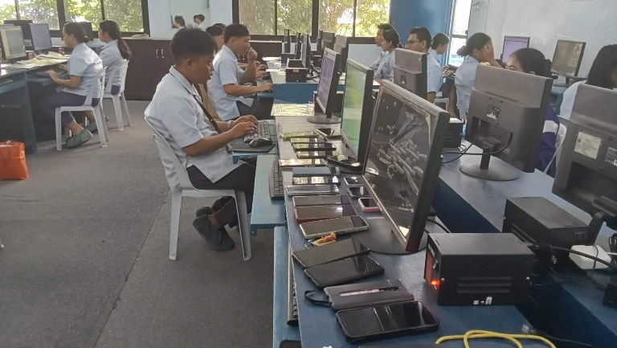

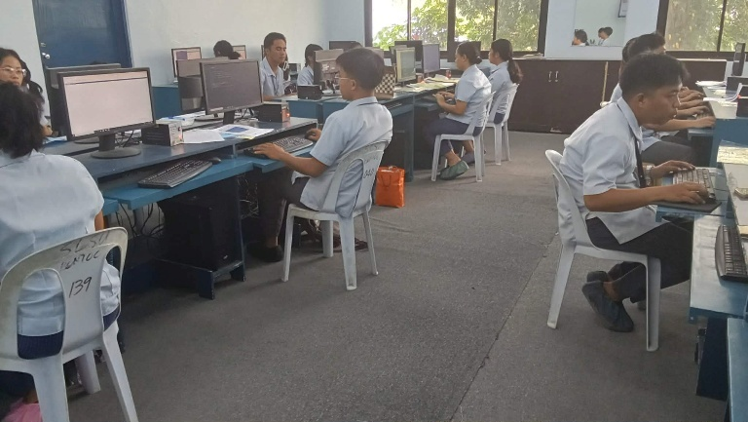

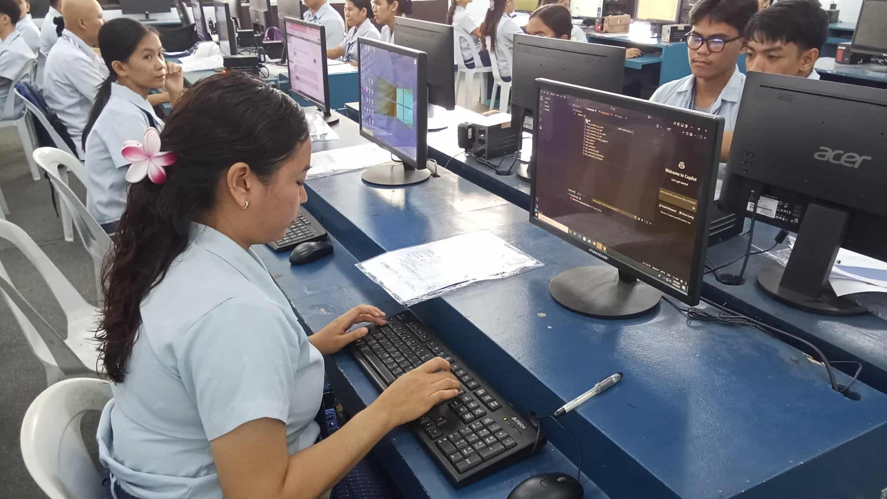
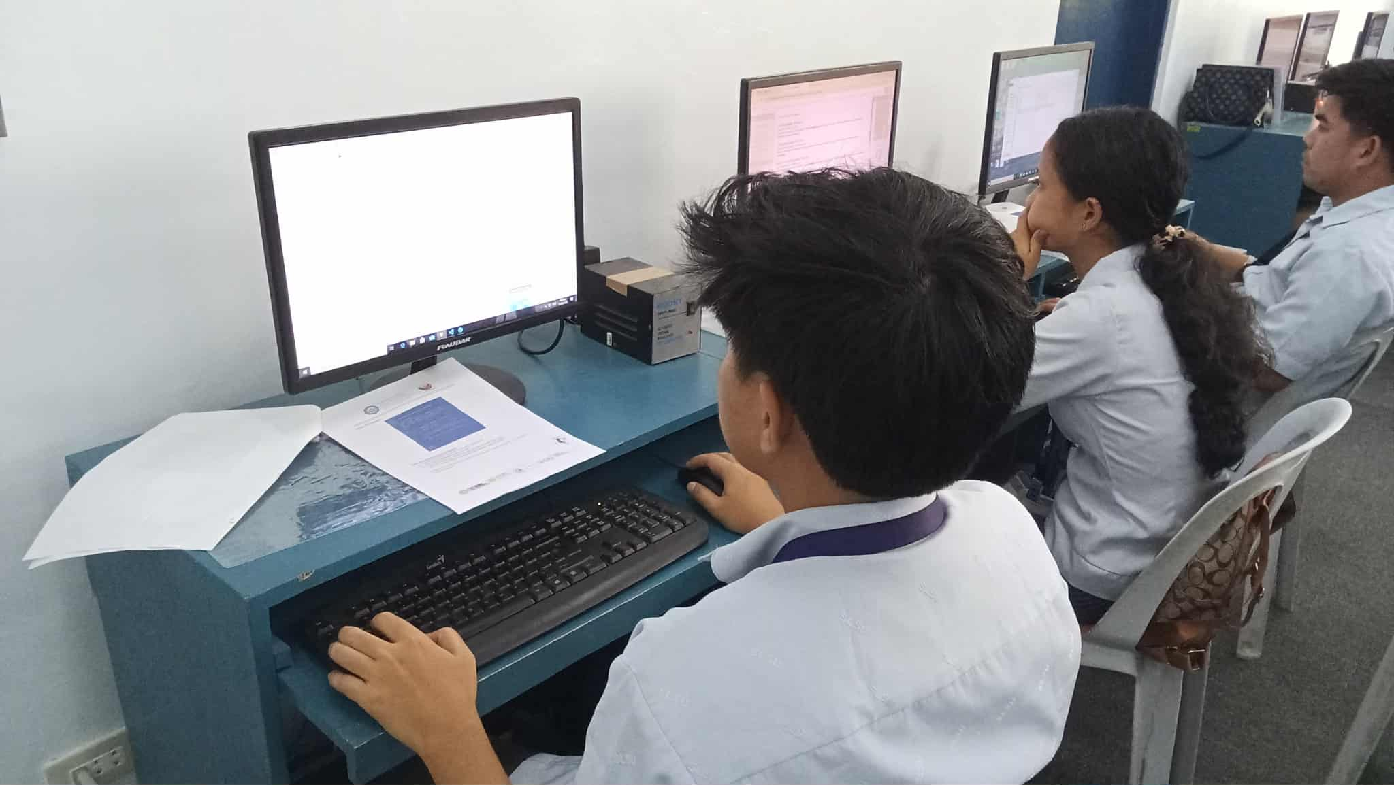
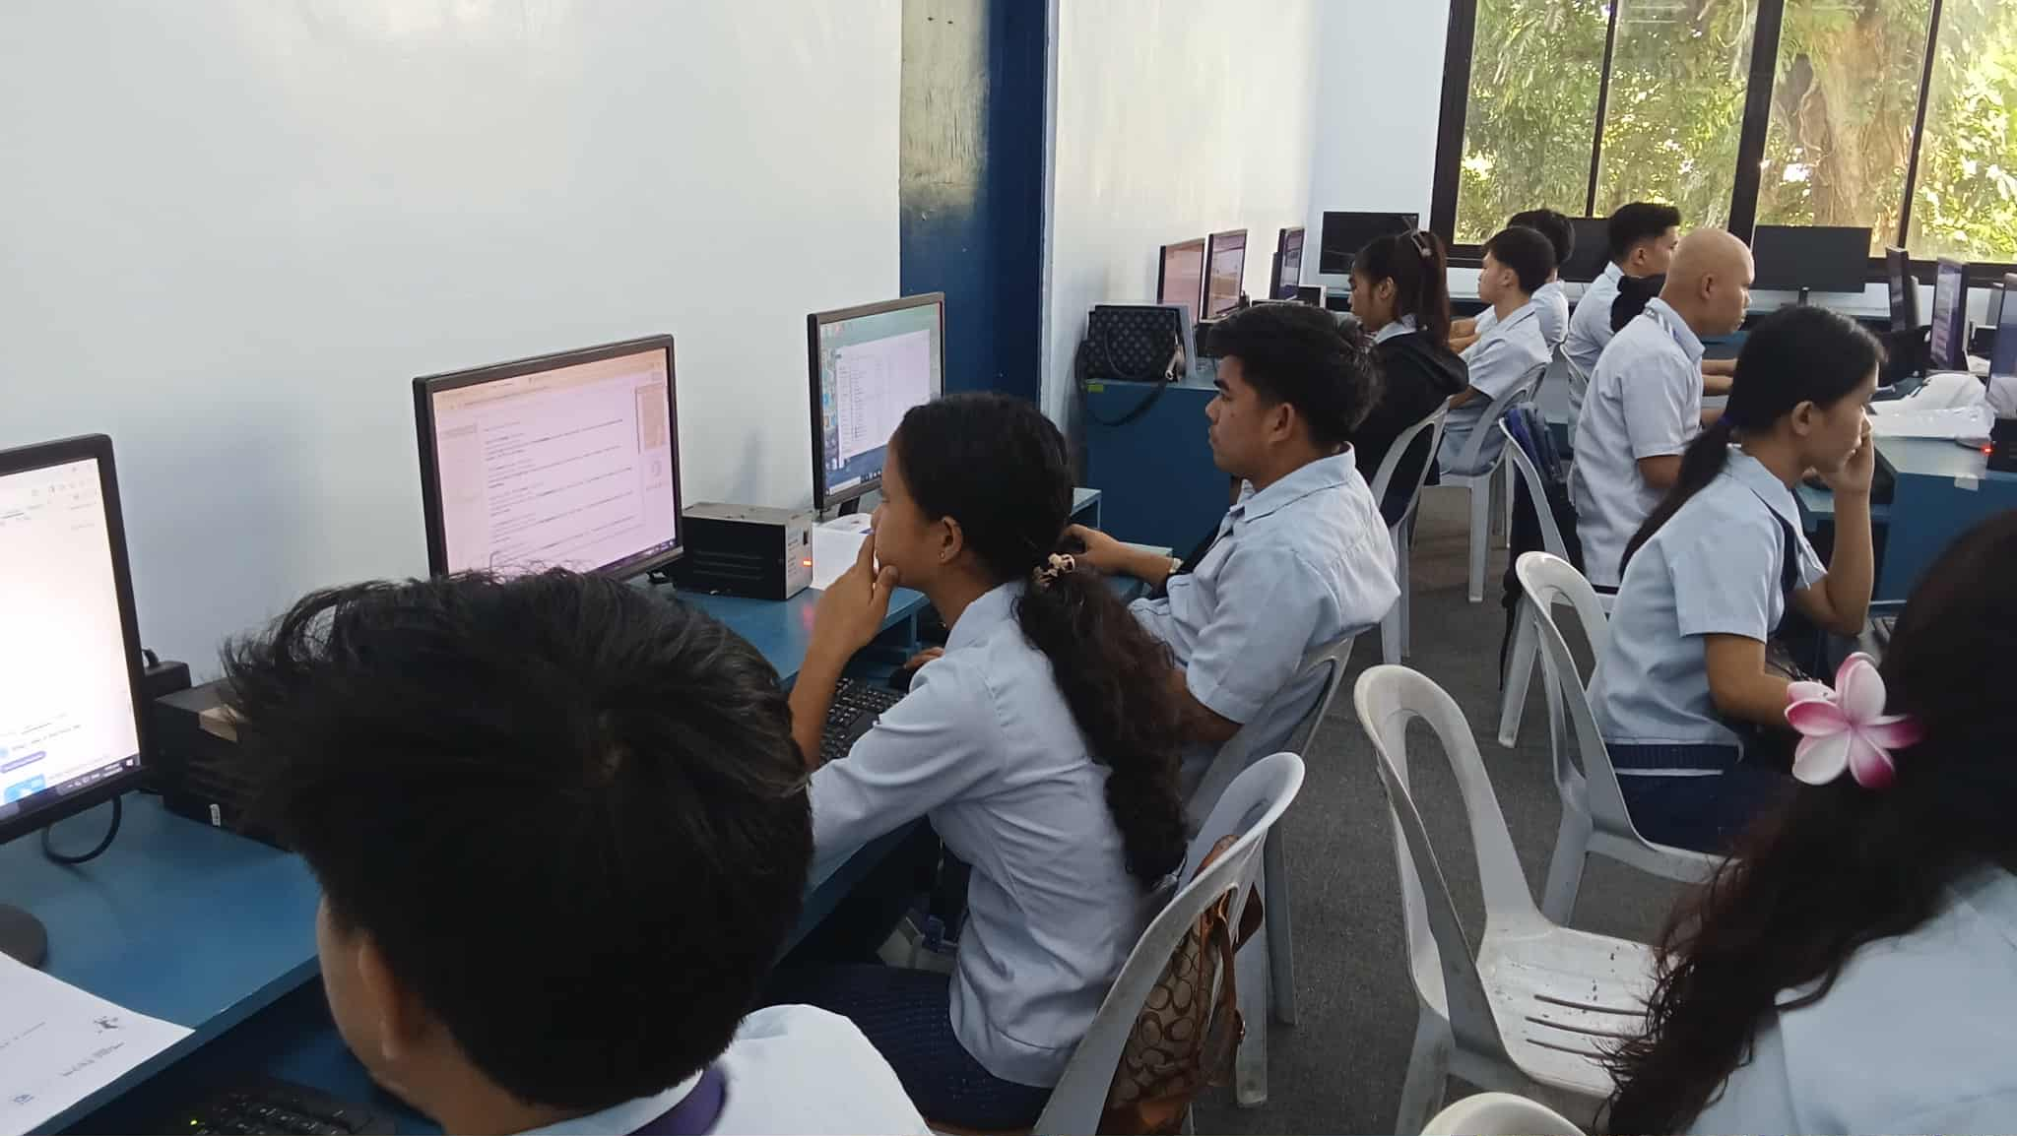
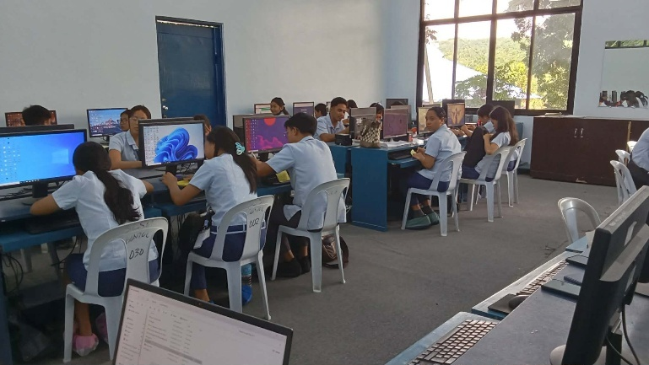

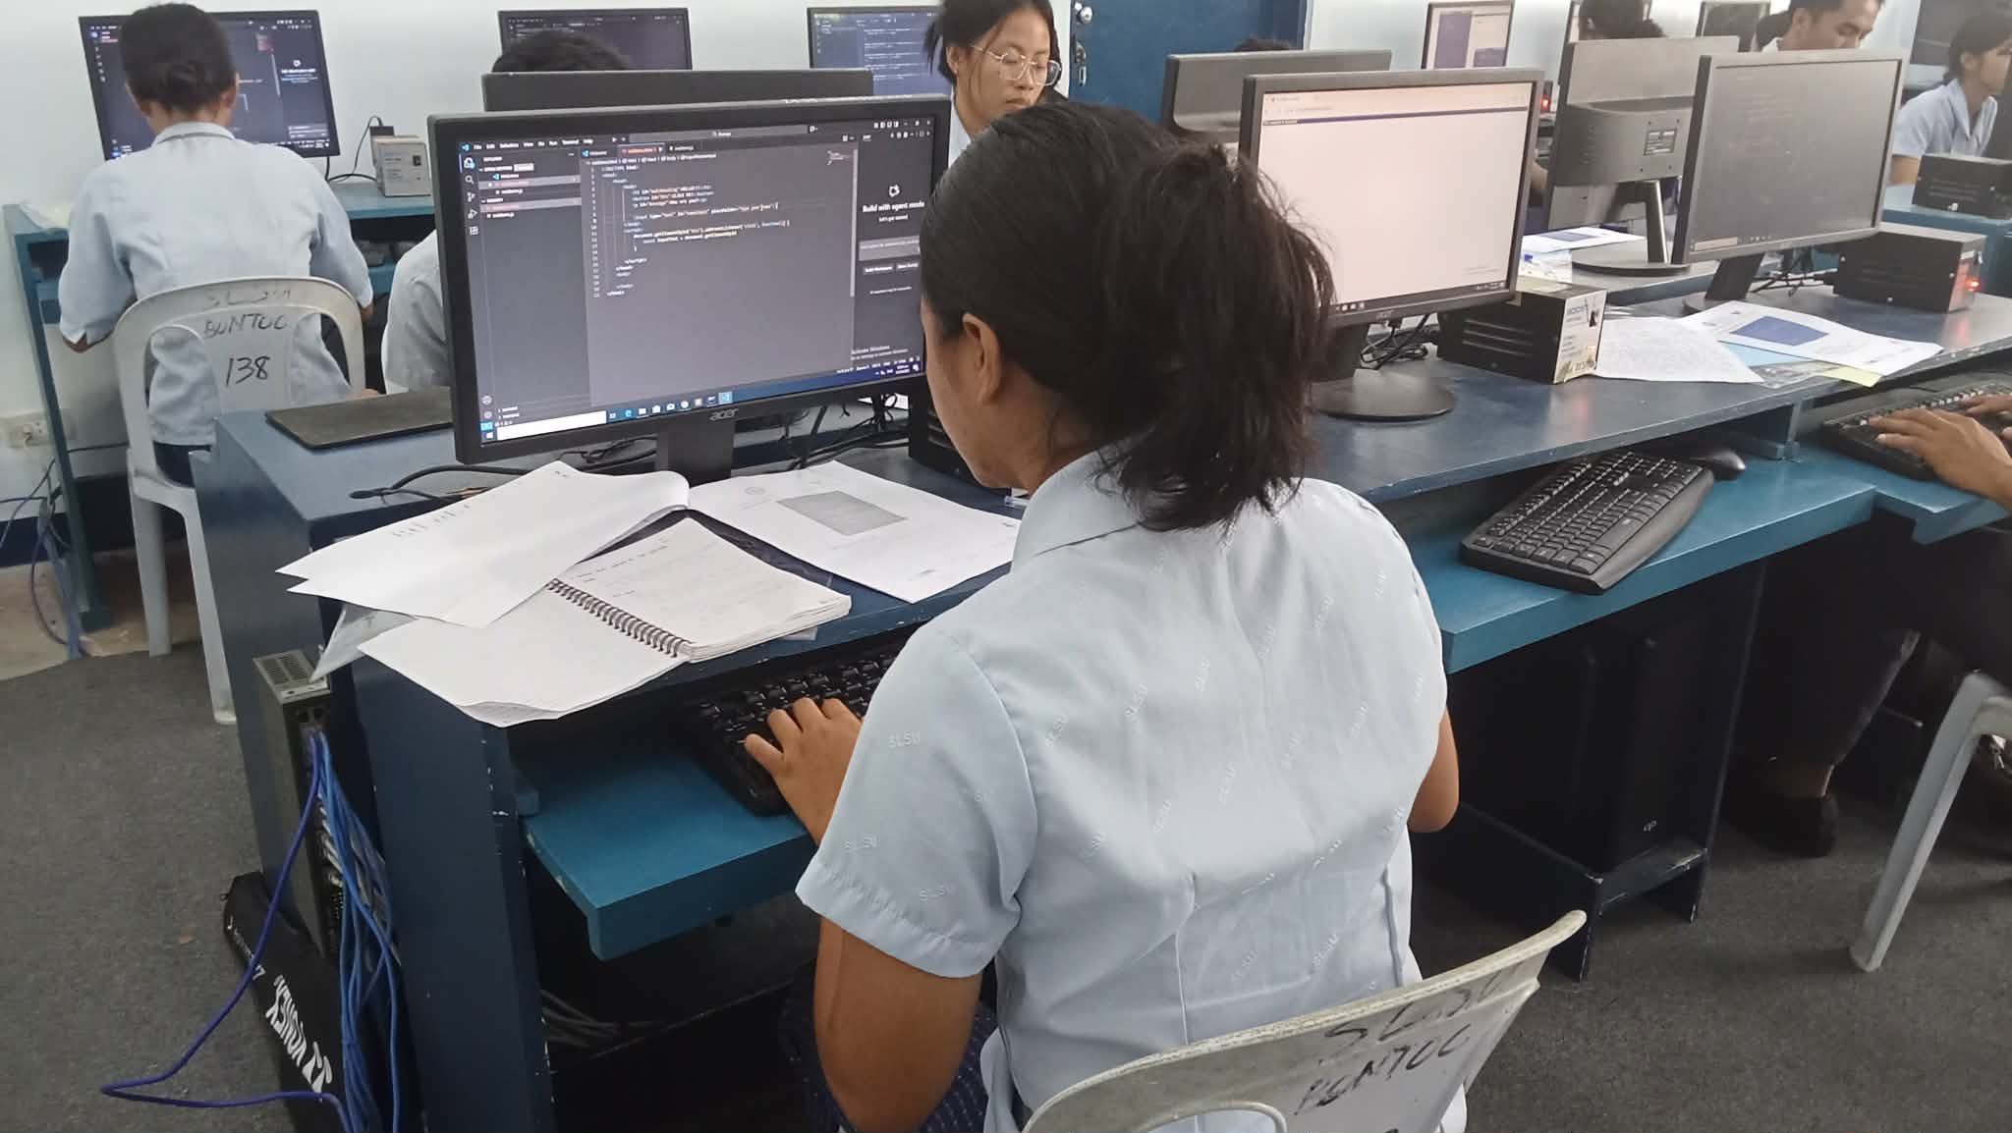
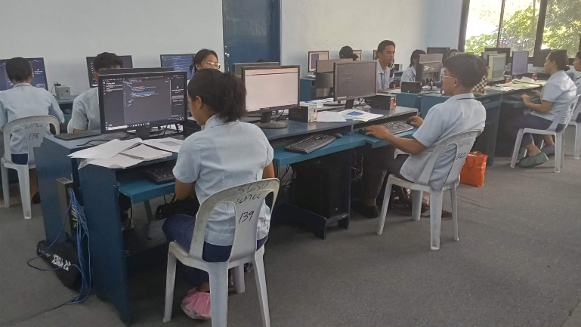
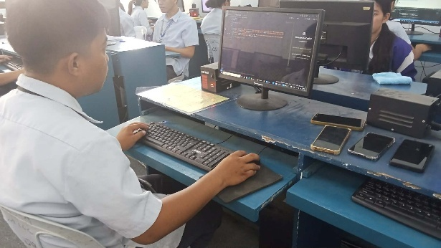

Prepared by: Approved:

JUNNIE RYH M. SUMACOT SHERWIN G. CADAY, PhD.
Instructor Program Chair

